JIMS ENGINEERING MANAGEMENT TECHNICAL CAMPUS
SCHOOL OF LAW
Plot No. 48/4, Knowledge Pak III, Greater Noida
(Affiliated to Guru Gobind Singh Indraprastha University, Delhi & Approved By Bar Council of India)

Event: Visit of Semester IV, BBA;LLB(Section A & B) students to DANM
Date: 21.02.2019
Venue: Dr. Ambedkar National Museum (DANM)
Metro Station, 26, Alipur Road Civil Lines Near Vidhan Sabha, New Delhi, Delhi 110054.
Report Date: 07.03.2019

REPORT

Constitutional Law II is a paper in Semester IV under which one of the PSDA is awareness about Fundamental Rights and Duties of citizens. Since it is an activity for personality development so I opted to introduce one of the founding father and chief Architect of Constitution by making visit of newly built Memorial so that the Class can become sensitive by observing the contribution and great works of Dr.B.R.Ambedkar.
The Prime Minister, Shri Narendra Modi inaugurated the “Dr. Ambedkar National Memorial (DANM)” at 26, Alipore Road, Delhi at the place of Mahaparinirvana of Dr. Ambedkar on April 13, 2018. The memorial is dedicated to the life and contributions of Dr. Ambedkar, the principal architect of the Constitution of India. This memorial has been given the shape of a book because Baba Saheb was the brain behind the drafting of the Constitution of India.
The Constitution of India has envisaged an inclusive approach towards civic life in a democratic institution. Certain rights have been guaranteed within the Constitution as Fundamental Rights under Part III. Constitution has also conferred certain duties, which are correlated to the rights and described as Fundamental Duties. The Fundamental Duties of citizens were added to Part IVA the Constitution by the 42nd Amendment in 1976, upon the recommendations of the Swaran Singh Committee. It is implied that whatever is required for the fulfilment of these goals be undertaken by every citizen as his duty.

The students of BBA LL.B IV were taken to the DANM with prior permission of concerned authorities. Overall 97 students visited the Museum on 21-02-2019 out of which 11 students availed the bus facility from campus. The visit were facilitated in three slots with 30-32 students each of 2.30 hrs duration in the DANM with allotted guide. The visit started from 11:30 am sharp and went till 2:00 pm.
The visit was conducted under the guidance of Rupesh Chandra Madhav and Haidar Ali.

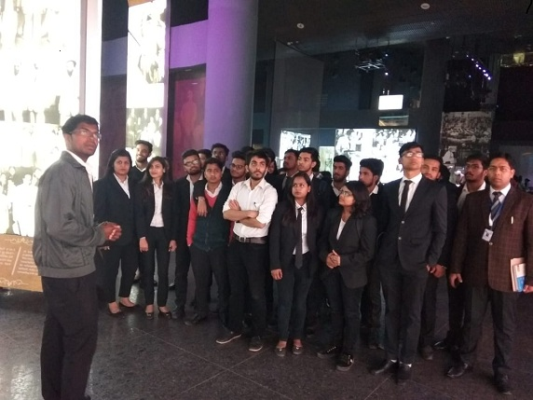

Image: One

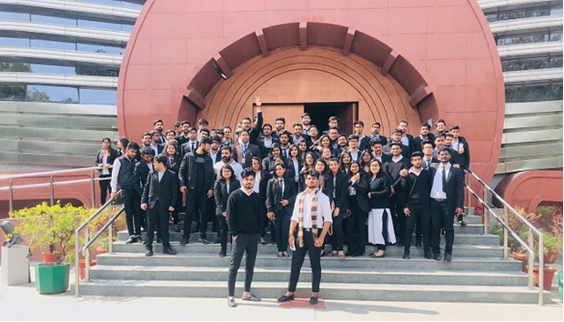Image: two

JIMS ENGINEERING MANAGEMENT TECHNICAL CAMPUS
SCHOOL OF LAW
Plot No. 48/4, Knowledge Pak III, Greater Noida
(Affiliated to Guru Gobind Singh Indraprastha University, Delhi & Approved By Bar Council of India)

Outcome of the event:

The visit was beneficial for the students as it provided a practical approach towards the concept of framing of Indian Constitution. Social Justice is the signature tune of Indian Constitution with other cherished goal set in Preamble. Students came to know about the original constitution that how Dr. Ambedakar lead his life with dignity after overcoming all social barriers. He showed the path of democracy to the largest democratic country of the world.

Faculty Coordinator HoD-School of Law

Encl: Students’ attendance

